作业三：

实现截图：

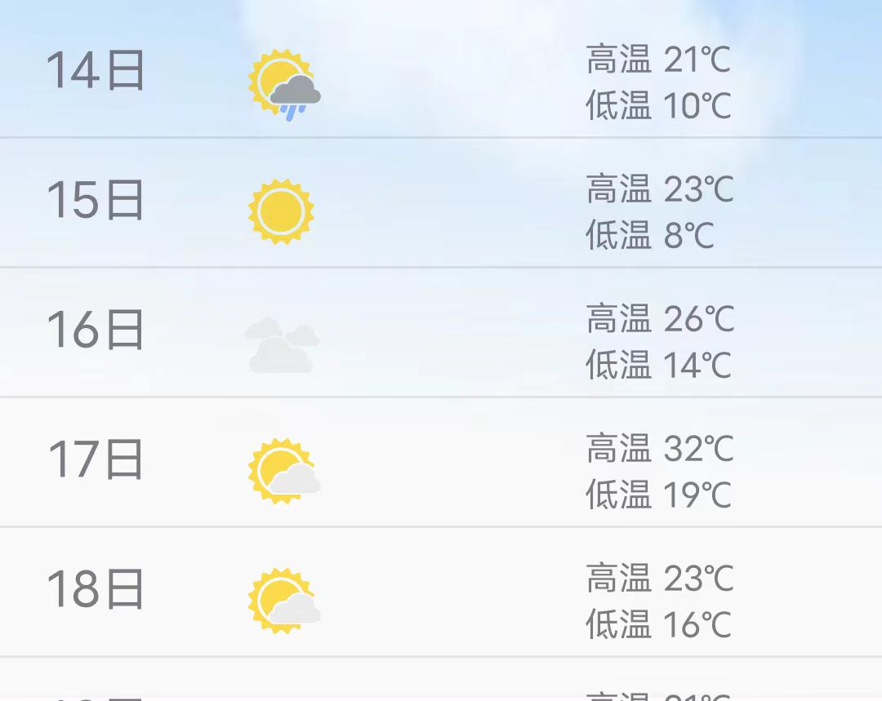

说明：

通过自定义Adapter实现在listView上实现自定义布局

关键代码：

1. 自定义Adapter并将布局应用于ListView

ArrayList<String> strList = (ArrayList<String>) msg.obj;

// ArrayAdapter adapter = new ArrayAdapter(Start.this, android.R.layout.simple_list_item_1, strList);

MyAdapter = new MyAdapter();

icons = (ArrayList<icon>) JSONArray.parseArray(load(), icon.class);

int resource = 0;

for (icon : icons) {

if (icon.getWeather().equals(todayWeather)) {

resource = getResId(icon.getLocation(), R.mipmap.class);

Log.i("weatherIcon", String.valueOf(resource));

break;

}

}

weatherIcon.setImageResource(resource);

listView.setAdapter(myAdapter);

1. 自定义布局

<?xml version="1.0" encoding="utf-8"?>

<androidx.constraintlayout.widget.ConstraintLayout xmlns:android="http://schemas.android.com/apk/res/android"

xmlns:app="http://schemas.android.com/apk/res-auto"

xmlns:tools="http://schemas.android.com/tools"

android:layout_width="match_parent"

android:layout_height="match_parent">

<TextView

android:id="@+id/Date"

android:layout_width="94dp"

android:layout_height="34dp"

android:layout_marginStart="16dp"

android:layout_marginTop="5dp"

android:paddingTop="5dp"

android:text="TextView"

android:textAlignment="center"

android:textSize="20sp"

app:layout_constraintBottom_toBottomOf="parent"

app:layout_constraintStart_toStartOf="parent"

app:layout_constraintTop_toTopOf="parent"

app:layout_constraintVertical_bias="0.018" />

<ImageView

android:id="@+id/WeatherType"

android:layout_width="56dp"

android:layout_height="40dp"

android:layout_marginTop="12dp"

android:layout_marginEnd="240dp"

app:layout_constraintEnd_toEndOf="parent"

app:layout_constraintHorizontal_bias="0.0"

app:layout_constraintStart_toEndOf="@+id/Date"

app:layout_constraintTop_toTopOf="parent"

app:srcCompat="@mipmap/haze" />

<LinearLayout

android:layout_width="105dp"

android:layout_height="41dp"

android:layout_marginStart="10dp"

android:layout_marginTop="10dp"

android:layout_marginEnd="30dp"

android:orientation="vertical"

app:layout_constraintEnd_toEndOf="parent"

app:layout_constraintHorizontal_bias="0.891"

app:layout_constraintStart_toEndOf="@+id/WeatherType"

app:layout_constraintTop_toTopOf="parent">

<TextView

android:id="@+id/high"

android:layout_width="match_parent"

android:layout_height="wrap_content"

android:text="TextView" />

<TextView

android:id="@+id/low"

android:layout_width="match_parent"

android:layout_height="wrap_content"

android:text="TextView" />

</LinearLayout>

</androidx.constraintlayout.widget.ConstraintLayout>

③自定义Adapter

class MyAdapter extends BaseAdapter {

@Override

public int getCount() {

return list.size();

}

@Override

public Object getItem(int position) {

return null;

}

@Override

public long getItemId(int position) {

return 0;

}

@Override

public View getView(int position, View convertView, ViewGroup parent) {

View view = View.inflate(Start.this, R.layout.item, null);

Log.i("todayWeather", todayWeather);

TextView textViewDate = view.findViewById(R.id.Date);

TextView textViewHigh = view.findViewById(R.id.high);

TextView textViewLow = view.findViewById(R.id.low);

ImageView WeatherType = view.findViewById(R.id.WeatherType);

Weather weather = list.get(position);

textViewDate.setText(weather.getDate()+"日");

textViewHigh.setText(weather.getHigh());

textViewLow.setText(weather.getLow());

int resource = 0;

for (icon icon : icons) {

if (icon.getWeather().equals(weather.getType())) {

resource = getResId(icon.getLocation(), R.mipmap.class);

Log.i("weatherIcon", String.valueOf(resource));

break;

}

}

WeatherType.setImageResource(resource);

return view;

}

}